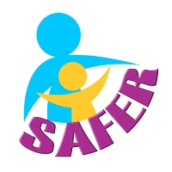
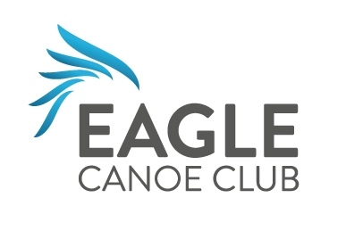
Children, Young People & Vulnerable
Adults Protection Policy

Designated WELFARE Officer | Hazel Roe 01953 602887
DEPUTY WELFARE Officer | Kate Pontin 01603 485525
DEPUTY WELFARE Officer | Emma Davey 07823 333830

The Club is fully committed to safeguarding the wellbeing of its members, by supporting coaches to maintain training and be compliant with British Canoeing validation requirements and for volunteers to have appropriate training and support.

Every member will sign the Club Code of Conduct and should show respect & understanding for the rights, safety & welfare of others & conduct him/herself in a way that reflects the aims of the club.

THE CLUB:
- Has a duty of care to all members, including children, young people & vulnerable adults and will do everything it can to provide an enjoyable, safe & caring environment whilst they attend club activities.
- Will request coaches to ensure that they have any essential medical information about their group members at each activity (either from the member or a parent/guardian)
- Will treat all children, young people & vulnerable adults with respect & celebrate their achievements
- Will ensure that all adult members complete a self disclosure form (and enhanced DBS checks for Coaches and Club Activity Assistants)
- Will respond to concerns and allegations appropriately
- Will follow Norfolk Safeguarding Children and Vulnerable Adult Procedures, and guidance in the British Canoeing Safeguarding Policies.

When there are concerns about the welfare of any child/young person/vulnerable adult or the behaviour of an adult, all members/adults/parents in our organisation are expected to share those concerns with the Designated Welfare Officer or Deputy.
They are responsible for:
- Monitoring & recording concerns
- Making referrals to Norfolk Children’s and Adults Services without delay
- Liaising with British Canoeing Safeguarding Officer
- Arranging Safeguarding training for coaches and adult members

Confidentiality:
In cases of disclosure of abuse, or concerns about a coach or volunteer, we are obliged to share the information with the Designated Welfare Officer or Deputy who may have to refer our concerns to Norfolk Children’s or Adults Services or the Police as appropriate

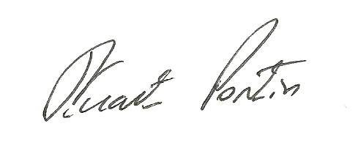
The Club will review this Policy annually:

Signed: Stuart Pontin

Date of Next Review: | March 2022

